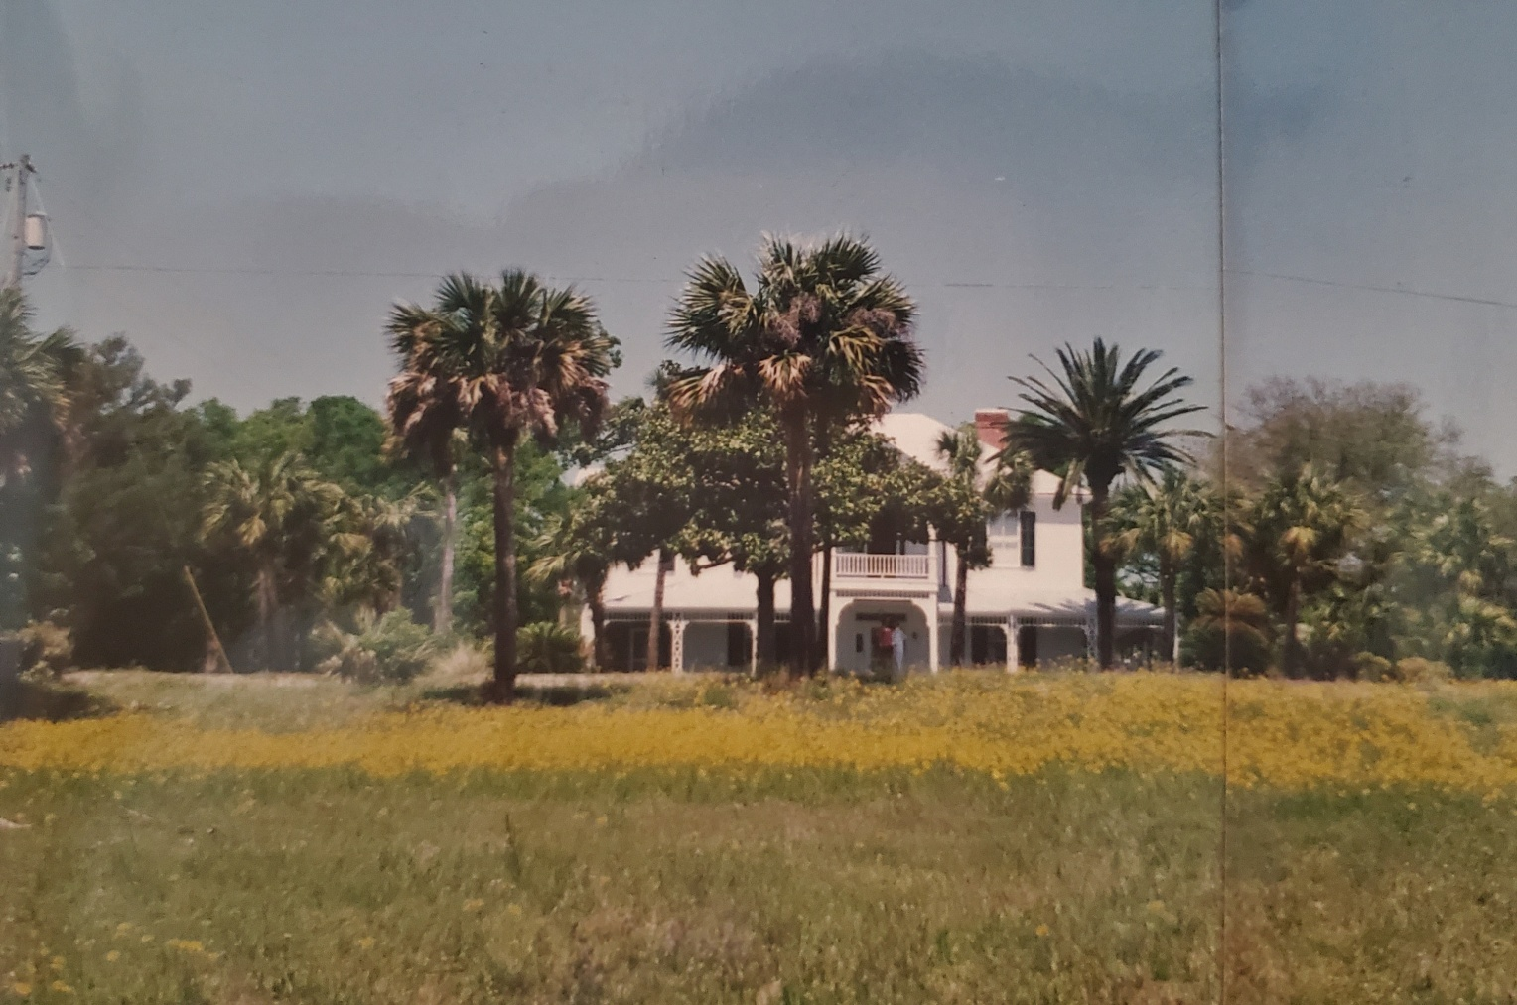

THE GRADY-HODGES HOUSE
127 Bay Avenue
Apalachicola, Florida

Researched and written by Pam Richardson
January 2020

This is a story of family. Not the tiny nuclear units that are the modern form of family, but the big, old-fashioned, multi-generational ones that are more like clans or tribes or even small nations - ones that imprint their members, no matter how far-flung, with a strong sense of identity and belonging.
It is a story of place, both geographic and spiritual, as well as a story of legacy, of an ethos passed down from one generation to the next for almost two hundred years.
Not least of all, it is a story of love.

The Grady family saga begins in the 1830s when a young man, Cornelius Grady of Killarney in County Kerry, Ireland, decided to follow his older brother, Patrick to the new and booming frontier town of Apalachicola in the Florida Territory, already the third largest shipping port on the Gulf coast. Patrick, reported variously as “employed in commerce” and working as a “laborer”, was living there with his wife, Mary, and their three boys – Henry, Cornelius and Patrick Jr. With merchants in Apalachicola making vast fortunes in shipping cotton from upriver plantations to places as far away as Liverpool, there was no shortage of work and opportunity. Patrick and Mary probably encouraged Cornelius to join them in this city that held the promise of a bright future for all. So, more than a decade before the start of Ireland’s devastating potato famine, Cornelius booked passage, probably in steerage, on a boat that took him from Cobh Harbor in County Cork to an unknown American port and from there he made his way to his brother’s remote town in northwest Florida. The earliest existing city tax records show that there were eventually three Grady brothers in Apalachicola: Patrick, Cornelius and Jeremiah. Jeremiah was a merchant and he remained on the city’s tax rolls until 1857. It is through Jeremiah that the first evidence of Cornelius’s presence in Apalachicola is found. In a January 1838 issue of New Orleans’s Times-Picayune newspaper, under the heading “Information Wanted!” a notice states that “in September 1835, Mr. Jeremiah Grady left Baltimore for New Orleans in company with Col. And Stephen Murphy. Any information respecting him, addressed to his brother, Cornelius Grady, at Apalachicola will be thankfully received.”

The city was growing fast, and carpentry was Cornelius’s trade. Given the availability of work and his probable zeal for making both money and a name for himself, it apparently didn’t take him long to do exactly that. In 1845, recognized for his talents, he was appointed Inspector of Lumber for Franklin County. Then, with an eye to settling down, he began courting Miss Elizabeth Lucas, a woman almost ten years younger than he.

Elizabeth, like Cornelius, was born in Ireland. At an unknown date, she, her parents (John and Elizabeth), her older sister Jane, and her brother Benjamin immigrated to the United States, settling in Belleville, New Jersey where her mother had four more children. Nothing further is known of the Lucas family until Jane married William Valleau of Apalachicola on September 20, 1842 in Jersey City, New Jersey. William was nearly two decades older than Jane and well-established in his adopted Southern city where he soon took up the offices of City Clerk (1843-1850), Master in Chancery (1846), Justice of the Peace (1850), and Mayor (1851). It appears that Jane’s entire family followed her and her new husband to Apalachicola. The records at Trinity Church report the confirmations of William Valleau (1843), Jane Lucas Valleau (no date given), Elizabeth Lucas (1843), and Ann and Margaret Lucas (1850). See the Lucas
and Valleau Family Trees in Appendices VI and VII.

Elizabeth Lucas and Cornelius Grady were married in March, 1845 and Elizabeth was baptized at Trinity Church on December 13 of that year. Their first child was born on December 13, 1846 and they named her Elizabeth, after both her mother and grandmother. A second daughter came soon afterwards, probably in 1847. Cornelius and Elizabeth named this girl Jane, in honor of Elizabeth’s sister, Jane Lucas Valleau. Their third child and first son, Henry, came into the family on May 14, 1848. It’s worth noting that brothers Cornelius and Patrick both named their first sons “Henry,” suggesting that their father’s name may also have been Henry.

By 1850, Cornelius and Elizabeth had three children and a fourth would soon be on its way. The growing family lived close to the mouth of the river in a house on the northwest corner of 4th Street and Avenue C. For the census that year, Cornelius gave his occupation as “carpenter.” Another source states that “Cornelius Grady was a successful contractor and builder at Apalachicola…[where] he and his brother Patrick were long men of prominence in business and civic affairs.”

Elizabeth Grady, who may have come from Protestant northern Ireland, became a faithful member of Trinity, but Cornelius and Patrick– whose family were Catholic – did not participate in the affairs of that church. They appear to have remained loyal to Catholicism and probably joined the ranks of the Catholic congregation organized in Apalachicola in 1845. There was, however, no physical church for them to attend until they built St. Patrick’s Catholic Church in 1852 (source: Lovett Family Papers).

The decade 1850-1860 was both a difficult and defining one for the Grady family. It began ominously with a powerful hurricane on August 23, 1850, followed a year and a day later by another. Just a few weeks after the second hurricane, on September 8, 1851, Elizabeth gave birth to her fourth child, Cornelius Grady, Jr. In the winter after his birth there was a cholera epidemic, perhaps the cause of the death of Elizabeth’s sixteen-year-old sister, Margaret Lucas. Cornelius weathered that epidemic, but his days proved to be numbered. He lived for only two years, dying in 1853. That same year, as if to counterbalance the family’s grief over baby Cornelius’s death, the fifth child, John E. Grady, was born. But, mercilessly, tragedy struck again a year later, in 1854, with the death of eight-year-old Elizabeth. Child number six, Cornelia, was born in 1855. Then in 1857, there was another heart-wrenching give-and-take: Cornelius Grady died when his wife was five months pregnant with their last child. Born on October 25, she was named Elizabeth, after her mother, her grandmother, and her deceased older sister, but the family called her Libby. In 1857 also, William Valleau died, meaning that the Lucas sisters became widows at essentially the same time. Both men died young: William was fifty-five and Cornelius was forty-five. In fact, old tax records indicate that all three Grady brothers – Patrick, Jeremiah and Cornelius – were struck from the list in the year 1857, giving rise to questions surrounding their disappearances. We know Cornelius died, but what of his two brothers? History is silent on the subject.

By 1860, then, the physical make up as well as the emotional fabric of the family had changed dramatically. Elizabeth, at age 38, was the head of the household whose remaining members were Jane (12), Henry (11), John (7), Cornelia (4) and Libby (2). Oddly, though, Libby’s name doesn’t appear on the 1860 census. Either she was not living with the family or, more likely, the census taker simply forgot to record her existence. That census also shows Patrick and Mary’s three grown boys (Henry, Cornelius and Patrick Jr) living together in Apalachicola, but their parents were gone, either by relocation or death.

When his father died, Henry Grady, Cornelius’s eldest son, was only nine years old. Nonetheless, within a few years, by virtue of both his character and birth order, he increasingly assumed the responsibilities of the man of the house. In what must have been a difficult decision for a boy with a sharp and curious mind, he chose to abandon his formal schooling in order to contribute financially to his family’s welfare. Despite this, Henry gave himself an excellent education. From an early age, and throughout his life, he was an avid reader, and he collected books on a wide variety of subjects.

In the year before the onset of the Civil War, a separate census was taken of the slave populations of the country. The information collected for Apalachicola shows “Henry Grady, agt” owning two slaves, both females. One was forty years old and blind, the other was thirty years old. Since Henry Grady was only eleven years old at the time, it may be presumed that these slave women, probably domestic servants, had been purchased by his father, Cornelius, before his death in 1857. The abbreviation “agt” after Henry’s name reveals that Henry, rather than Mrs. Grady, was recognized as Cornelius’s representative, or agent. Cotton was shipped to and from, but not grown in, Apalachicola, so there were fewer slaves in this port town than in more agricultural parts of Florida. Nonetheless, slaves consistently made up about 25% of the total population in the years preceding the war.

During the war, Union forces set up a blockade in the bay which prevented nearly all shipments from entering and leaving Apalachicola, and this created shortages and hardships for the people living there. In January 1861, when Florida seceded from the Union, many of Apalachicola’s merchants - who were Northerners - returned home; about a year later, when Confederate troops withdrew from the city and Union forces occupied it, even more citizens fled to Georgia and Alabama to ride out the war. This may be when Patrick Grady’s son, Henry, and his new wife, Mary Ann Sloan, went to Eufaula, AL where he continued to be employed as a carpenter (see the Patrick Grady Family Tree in Appendix V.). Patrick’s middle son, Cornelius, enlisted in the Confederate Army as a private in Dunham’s Company, but nothing further is known of either him or the youngest son, Patrick Jr. This may also be about when Elizabeth Grady’s widowed sister, Jane Lucas Valleau, went with her son and daughter to live in Jersey City, NJ, where she remained until her death. As for Mrs. Grady, Jane, Henry, John, Cornelia and Libby, they all stayed put. No stories have been passed down of what those years were like for the family, but they could not have been easy. Food was so scarce that “what saved the people from starvation were the abundant fish and oysters in the bay.” At the end of the war, there was a brief resurgence of Apalachicola’s former prosperity, and Henry, who was seventeen, started in the mercantile business. Four years later, in 1869, Henry was elected to the Vestry at Trinity Church, an organization he would faithfully serve for the next sixty-six years.

Henry was an eligible young bachelor, and in the early 1870s Miss Mary Porter Raney, known to all as Mamie, caught his eye. Her father was the prominent merchant, David Raney. For some time, Henry and Mamie kept company in the evenings on the front porch of the Raney House. What put an end to their courting is not known, but it may have been a consequence of Mamie’s sister’s death from yellow fever in 1875. That sister had given birth six months earlier to a baby boy and Mamie, already tending to her mother, took on the added responsibility of raising her infant nephew. Another explanation for the end of Henry and Mamie’s relationship might be that Mamie’s mother wouldn’t have it; she thought Henry Grady wasn’t ‘good enough.’ Whatever the reason, Mamie remained single for the rest of her life - as did Henry, who “never found it expedient to release himself from the ranks of bachelors in Franklin County.” Instead, he turned his attention to politics.

In 1877, when he was not quite thirty years old, Henry became Clerk of the State Senate, and in 1879, 1881 and 1883 he served as Franklin County’s Representative in the Florida Legislature. He would become known as “a vigorous and liberal supporter of progressive movements and enterprises tending to advance his home city and county.” He also became both a City Councilman and a leader in the local council of the Democratic party and spent over forty years as a member of the state Democratic Executive Committee. In these roles, as in all his undertakings, Henry earned the deep respect of his colleagues and his community. So much so that not once, but twice – on the occasions of his 73rd and 87th birthdays – he was publicly honored by them, as will be seen later.

Other changes in the Grady family during the decade 1870-1880 include the disappearance of the eldest living child, Jane. She appears on the 1850, 1860 and 1870 censuses, listed once as older than Henry and twice as younger than he. In 1870, she was about twenty-one years old, living at home with her mother and her siblings, but that is the last time any mention of her can be found. There are not even any surviving stories of her. It is assumed that she died, but there is no trace of her in Apalachicola’s cemeteries. Equally mysterious is another young woman, Jenny Grady, found in the yellowed pages of Trinity Church records. The similarity of their names as well as their ages suggests that they may have been the same person, however the old record says that Jennie Grady’s given name was Virginia. She married Amos Andrew Cordson on February 4, 1873 “at the home of Mrs. Grady,” and then moved with Amos to Bainbridge, GA where she died about a year later, probably in childbirth. Her prayer book, inscribed with the name “Jennie Cordson,” is in the Archives Room at 127 Bay Avenue. Until it can be proved otherwise, it is plausible that Jennie/Virginia and Jane were indeed the same person.

In 1876, Charles H. Parlin, a Civil War veteran of the Union Army and a Republican from the state of Maine, arrived in Apalachicola and began courting Cornelia Grady. Charles, descended from a 17th century Cambridge, Massachusetts family, hailed from Skowhegan, Maine where he was born on February 12, 1837 – so, he was almost twenty years older than Cornelia. In the late summer of 1862, he enlisted in the 16th Maine regiment and served first as Commissary Sergeant in Company K and later as 2nd Lieutenant in Company D. He was said to have been one of the first Yankees to cut a chip out of the legendary apple tree at Appomattox as a memento. He was sent to Florida where he served for a number of years at the Pensacola Navy Yard and contracted malaria. After recovering, he came to Apalachicola.

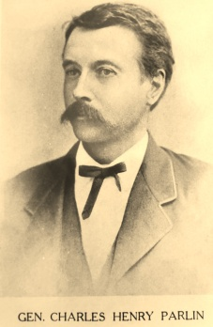
Charles Parlin, as a young man. In later years, he was made Surveyor General of Florida, hence his title of General.

Charles and Cornelia married on her twenty-fourth birthday, August 12, 1879. At the time of their marriage, Apalachicola had lost most of its pre-war glory. Here is a depiction provided by the office of the Customs Collector in 1879:

Apalachicola has a population of 1,000 or 1,200. It was immediately after the war, a very flourishing place, and was the third or fourth cotton port in the United States. But the same commercial influences that have destroyed St. Marks, namely the diversion of trade by the railroads to the Atlantic coast, have also robbed Apalachicola of her commercial importance. Many businesses have fallen into ruins. The streets are literally overgrown with grass. No carriages or buggies are used in the place. There are no wheeled vehicles to be seen except three or four drays or carts. In a word, the dilapidation of the place is extreme. The exports now consist of pine lumber (there is one sawmill), sponges, fish and oranges.

It may be no wonder, then, that within a few years the newly married couple went to live in Carrabelle, where Charles partnered with James N. Coombs, another Maine man, in the lumber business.

The 1880 census shows a decidedly smaller Grady family in this down-at-the-heels place. Henry, age 32, working as a grocer, and John, age 27, “a clerk in a store,” were living with their mother and sister. Libby, short, bird-like and full of nervous energy, was in her twenties at that time, but showed no interest in finding a marriage partner. Instead, she busied herself with church-related activities, caring for the family’s home and, increasingly, tending to her aging mother. She was for many years the corresponding secretary for both Trinity Church and the Chestnut Cemetery Association.

In 1883, when Henry was serving his second term as a Representative in the Florida legislature, John joined him there. The Grady brothers were making a name for themselves not only in politics, but also in business. In both arenas, Henry and John were prominent players in the difficult task of revitalizing Apalachicola. In 1884, John started what became his immensely successful ship chandlery business, J E Grady & Company. Henry came on board as a partner, and while he probably assumed many duties, his primary job was that of bookkeeper.

It has been suggested that Henry may have been “a reluctant capitalist.” Despite long hours spent at the store, it is evident that Henry’s main mission in life was to serve - his family, his city, his state, and his church - hence his early reputation as a good and kind man. In whatever time was left over after service and work, he could be found reading, gardening or relic-hunting. There are few photographs of Henry, but a visual memory of him has been passed down through the generations: he would often sit in his Morris chair, directly under an overhead light in the parlor; there, kept company only by the dozens of books in the bookcases lining the front wall, he would read long into the night. From time to time, putting his book aside, he would replenish the coal in the fireplace from the scuttle next to it or play a few rounds of Solitaire. All his life, Henry was a keen reader and student, especially of history, and it was claimed that no other citizen of Franklin County knew as much about the history of that entire section of the state.

One of Henry’s favorite pastimes was to go digging in the many Indian mounds between Apalachicola and the area west of the city called “Thirteen-Mile” as well as out beyond Magnolia Cemetery where there was a cluster of thirteen mounds. From these sites, Henry collected a large number of Native American artifacts, including Fort Walton-period (1200-1500 CE) ceramics, pipes, shell pins, shell and stone tools and more. Henry sent many of these off to the University of Florida at Gainesville until they wrote him a letter, asking him not to send them anymore Indian bones! After his death, Henry’s heirs donated Henry’s collection to what would become the Florida Museum of Natural History.

The year 1884 brought with it that now familiar partnership of grief and joy. Elizabeth, the matriarch, died on March 25 at the age of sixty-two. Trinity’s records state that she was “the mother of Henry Lucas and John E. Grady, prominent in the town and church.” (The way the sentence is written doesn’t make clear whether “prominence” applied to Elizabeth or to her two sons, but the characterization was true of all three.) With Elizabeth Grady’s death, the family, the church, and the city all lost an esteemed member. Six months later, on September 24, the family witnessed and celebrated John’s marriage to his sweetheart, Alice St. Clair Hartman. He was thirty-one and she was twenty-three. (See Appendix I.)

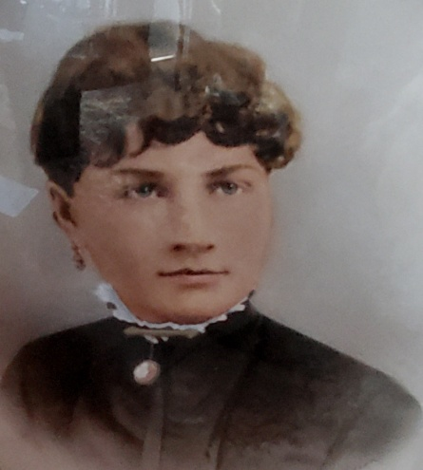
Alice St. Clair Hartman,
wife of John E. Grady
1861-1884
(with apologies for the reflection in the photo)

The last noteworthy event of 1884 was John’s purchase, along with two other partners, of “everything pertaining or belonging to the Apalachicola Tribune newspaper” which, several months later, merged with the Herald under the new name of the Apalachicola Times. How much John had to do with the new newspaper is unknown but, even if his only contribution was as financial backer, his part in the purchase of the Tribune was an indication of his growing wealth and position within the city.

In January following their marriage, Alice became pregnant, and the couple’s future glowed with promise. However, when it came time for Alice to deliver in October, tragedy visited yet again: Alice developed puerperal fever, causing the deaths of both herself and her baby. John was certainly no stranger to misfortune; he had prematurely lost his father, two sisters and a baby brother, but this newest calamity completely eclipsed the earlier ones. And this time, life offered no counterpoint to grief. After Alice was buried in the family plot in Chestnut Cemetery, John somehow continued to build his chandlery business and to fulfill his obligations as the newly-appointed Collector of Customs, a much sought-after political patronage job. That he found the will and drive to carry on in the face of such profound loss speaks volumes about his character. John’s particular attributes were publicly recognized a few years after Alice’s death in the following paragraphs:

Mr. John E. Grady, the proprietor of the house [ J. E. Grady & Company], is one of the most popular, influential, enterprising and reliable gentlemen in Apalachicola. The writer has no hesitancy in saying that what he sanctions is seconded by the entire city. Unassuming, yet always among the first in enterprise to benefit the city, he is recognized as a leader in all movements.
A man of sterling integrity and remarkable executive ability, he has held several prominent
positions. He was a member of the legislature in 1883; was appointed Collector of Customs in 1885; is a Royal Arch Mason and a Knight of Honor.
He has been engaged in the ship chandlery and general mercantile business for a number of years, and has the largest warehouse and does the largest business in the place. He never carries less than $25,000 worth in stock. He was one of the few gentlemen who stood by Apalachicola in the dark days, is a true Democrat, and a firm believer in a bright future for “Apalach.” Such a man is John E. Grady.
Masons Posing in the Street, Apalachicola, 188?, Florida Archives
John Grady is 7th from left.
His Masonic ring is among the family artifacts at 127 Bay Avenue.

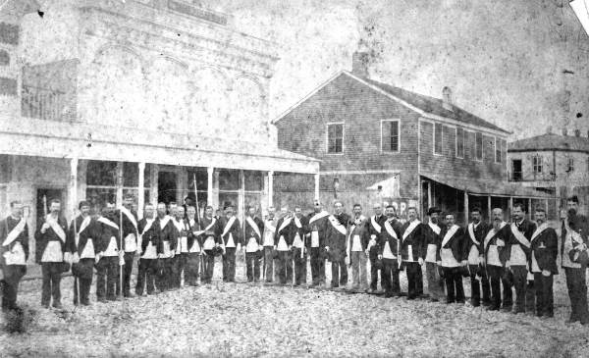

In what must have been a bittersweet event for John, in 1886, his sister Cornelia gave birth to her third child, a daughter whom they named Alice St. Clair Parlin, in honor of John’s recently deceased wife. 1886 was also the year Henry became Senior Warden of the Vestry at Trinity Church, a position he would hold until the last years of his life. In 1887, John, also an active member of the Vestry, was on a committee that canvassed the town seeking donations for the minister’s salary.

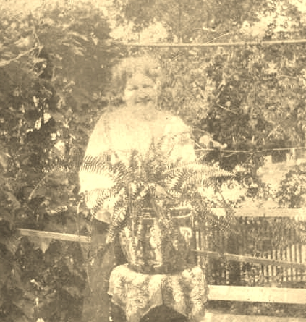
Cornelia Elizabeth Grady Parlin

In 1889, John moved his chandlery business from 42 Water Street (next to today’s History, Art & Culture Center) a few doors south to 38 Water Street. A fire the following year burned seventeen buildings downtown and John’s was one of them, but he wasted no time in repairing and rebuilding and was soon back in business. At the same time, he and another prominent Apalachicola man, John Ruge, were elected as delegates from Trinity Church to the diocesan council.

1891 was the year Henry Grady purchased the house at 127 Bay Avenue and four abutting lots from his sister-in-law (See Appendix II). This may have been motivated by the family’s decision to have five-year-old Alice St. Clair Parlin (“Alice II”), who lived with her parents and siblings in Carrabelle, come to Apalachicola for schooling. Alice attended Miss Steppie Rice’s and Mrs. Marks’s schools and lived with Henry, John and Libby, usually going home in the summers. This arrangement became permanent and Alice Parlin was, in fact, raised by her three unmarried relatives, Nunka, Uncle Ja, and Aunt Libby, as she called them. As a child, little Alice loved to ride her bicycle on the wide front porch, but she was also known to ride it from the back door, down the hall, out the front door and right on down the steps onto the oyster shell walkway. She was, from an early age, full of life and laughter, and she not only aided in John’s emotional convalescence, but also brought him and the rest of the family much joy.

Alice’s last sibling, Alma Bodfish Parlin, was born in 1892. She joined Charles “Mac” Grady Parlin (1880-1940) and May Burrill Parlin (1882-1935) in Carrabelle with their parents, Cornelia and Charles. Cornelia, called “Mamam” by the family, was a peppy person who didn’t beat around the bush; she was
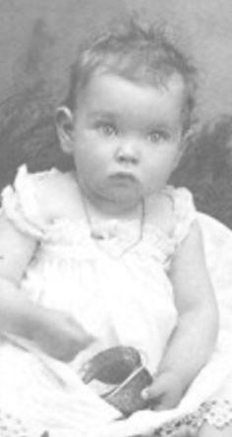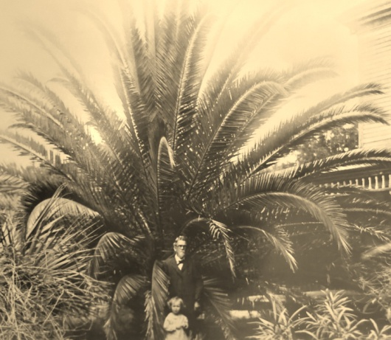
Alice St. Clair Parlin
(1886-1987) or “Nonnie” as baby, left.
Alice St. Clair Hodges or “Little Alice”(1921-2006) with Nunka
and his date palm
at 127 Bay Avenue

opinionated and had no hesitation in telling you exactly what she thought. She could also be “prickly,”
a characteristic apparently inherited by her daughter, Alma. Her husband, Charles, on the other hand, was more like Henry, kind and patient.

After the family took up residency at 127 Bay Avenue, then called Market Street, Henry created a lush garden around the house. In the front yard, he set out fruit trees and a date palm that grew to a great height before finally coming down in a storm in the 1980s. In the back yard, he established a scuppernong grape vine which is still there today. Across the street, nearer to the water, Henry put in a grove of grapefruit trees. He also planted the Cherokee Rose whose white blooms cascaded, for many decades, across the west side of the house. Henry’s fascination with Native American history may be what led him to choose this rose. Its white petals are said to represent mothers’ tears, its yellow centers symbolize the gold taken from Cherokee lands, and the seven leaves on each stem stand for the seven Cherokee clans that were forced to leave their homeland in 1838 and plod westward on the Trail of Tears.

1893 marked eight years since John’s wife’s passing and, while he still showed signs of suffering,his recovery from that loss is reflected in his remarkable standing in the community and the state. J. E. Grady & Co was running as a successful enterprise and John was serving as a member of the Florida Senate and the Florida Board of Health. That year, he was appointed to a second four-year term as Apalachicola’s Collector of Customs. He also continued to buy and sell a lot of real estate. From 1885 to 1904, there are sixty-three recorded real estate transactions, many of them tax sales deeds, under John Grady’s name. His obituary described him as “one of the largest real estate owners in that section of the state.” Despite this, he never chose to leave the Grady home at 127 Bay Avenue where he lived in a separate detached building (perhaps a former kitchen) fronting on 10th Street.

Locally, the most remarkable event of 1894 may have been the thermometer’s drop to 14 degrees two days after Christmas. It happened again about six weeks later when, the sap being up, all the orange trees in the area were killed, including a fine grove at Old Woman’s Bluff. That spring, a Board of Trade, made up of the most prominent businessmen in Apalachicola, was organized, and it elected John E. Grady as its president. He faithfully attended all future meetings of this Board and was later chosen, along with his friend John Ruge, to represent it in Washington, D.C.

Despite a national economic depression, a destructive hurricane (1898) and a severely cold winter (1899), life for the Grady family continued on happily for the next few years. But, on May 25, 1900, a fire started in the kitchen of the Methodist parsonage and, fanned by shifting winds, it eventually consumed most of Apalachicola’s downtown. The J.E. Grady & Co building and warehouse were two of the victims. John set about rebuilding immediately – as he has done in 1889 - and he was soon up and running again. A newspaper article about the rapid restoration of the city’s downtown included the following high praise:

One of the old established business firms of Apalachicola is that of John E. Grady & Co., Ship Chandlery
& Groceries. Mr. Grady began life with no heritage of wealth; hampered by early orphanage [sic], he
became prominent because of his own efforts, by his own self-made resources. Whether in business
transactions or in politics, Mr. Grady is a man of his word and the soul of honor. He is President of the Board of Trade, and has held many positions of trust, and has at heart the welfare of his native city and
all that pertains to her progress.

However, only two months after the fire, John must have fallen ill or felt some kind of premonition of his death because he gave his brother Henry power of attorney over all his affairs.

In 1904, Alice graduated from high school and went off to Florida State College for Women in Tallahassee. She stood only five feet one inch tall in her bare feet, but was nonetheless on the first women’s basketball team there. She was a beautiful and vivacious young woman with big eyes and black hair. In those days, the trip back to Apalachicola entailed one long horse and buggy ride, a ferry crossing and then a short buggy ride, but Alice came home often.

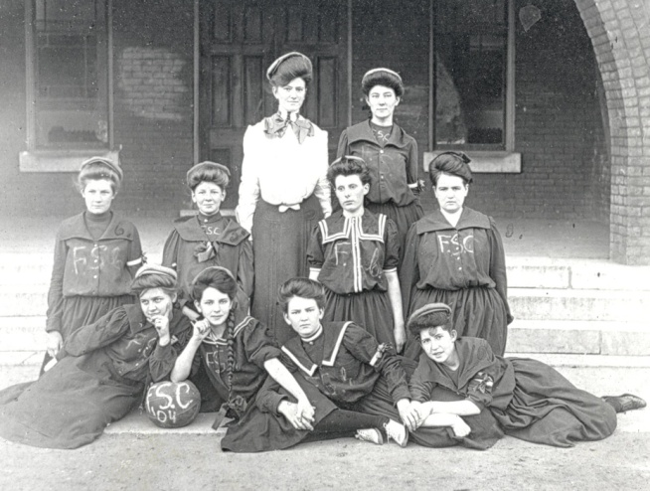
Alice St. Clair Parlin, a member of FSCW’s first basketball team, is sitting second from left in the front row. This photograph is a large mural in the practice center at Florida State University, Tallahassee.

On the night of Thursday, April 13, 1905, John’s premonitions proved true. He died of heart failure at fifty-two years of age, seven years older than his father and the same age as his uncle when they had passed. All good men, gone too soon. John’s front page obituary in The Pensacola Journal uses the word “prominent” five times. The city had lost a great man. After his death, it fell to Henry, as the last male in his immediate family, to carry on the family’s legacy. He took over his brother’s business and soon welcomed his sister’s son, Charles (“Mac”) Grady Parlin, as a business partner. Charles’s father, Charles Henry Parlin, was at the time finishing up his career as the last Surveyor General for the State of Florida; he returned to Apalachicola when that position was abolished about 1908, but died of Bright’s Disease on September 20, 1910, a month shy of his daughter Alice’s marriage. His funeral was held at Trinity and he was buried in Magnolia Cemetery. His obituary extols him as “generous to a fault” and “one of the most companionable of men” with his friends numbering in “the hundreds.” An historic marker, memorializing him, stands today in Tallahassee’s Cascades Park.

Alice’s fiancé was Joseph Harper Hodges, born in Gadsden, Alabama in 1877. He worked for the Apalachicola Northern Railroad, which is what brought him to Apalachicola in 1907, the year the city finally got rail service. His job was general agent for passengers and freight. In view of her father’s recent death, Alice and Joseph’s marriage took place with little fanfare. A private wedding was held at her sister May Graves’s house, two doors west of the Grady home, and there was no reception. But, to make up for that, six months later Joseph Hodges hosted an Easter dance at the Franklin Hotel in honor of his new wife. The young couple lived for a time at the Franklin while they waited for their house to be readied. Henry gave the house to them as a wedding present. It stood (and stands today) on Lots 4 and 5 behind 127 Bay Avenue and was moved from Port St. Joe at an unknown date. Joseph and Alice added John Grady’s separate dwelling onto the south side of the house on Lots 4 and 5. Ever after, they called their house “The Cottage” and the addition to it “The John Grady Room.” The Cottage and the main Grady house, as well as their occupants, were so closely related as to be almost one. In fact, Joseph and Alice’s first born child, John Grady Hodges (1911-1998), moved into the main Grady to live with Nunka and Aunt Libby when he was five years old, just as his mother had done. This no doubt eased things for Alice who, at the time, had three pre-school children to care for: John Grady Hodges, Joseph Harper Hodges, Jr (1913-2005) and Sinclair Parlin Hodges (1914-1917). Their only sister, Alice Hodges (1921-2006), came later, after little Sinclair had died of diphtheria. The three elder Gradys, already devoted to their nieces and nephews, poured their love into this next generation of children.

Joseph Hodges was a quiet and distinguished man who all his life was a steady presence in the family. He dressed impeccably in three-piece Brooks Brothers suits, with a straw fedora in the summer and a felt hat in the winter. He was often funny, without intending to be, and played straight-man to Alice and her sister, May. He loved to go to the movies and every time a new movie came to town, he would go to the Dixie Theater and sit, with his hat on, in the back row on the right. Alice rarely went with him because sitting quietly was not her idea of a good time. This was only one of the ways in which they differed. Another was found in their religious involvement; Trinity Church played a large role in Alice’s life, but Joseph was a Presbyterian and never went to church with his family. A sweet mental picture of him comes through his granddaughter Kathy, who called him “Dee.” Always neat and dignified, he would good-naturedly brush away the flour dust that Alice, in her usual careless fashion, managed to spread all over his suit when she came from the kitchen to welcome him home from work.

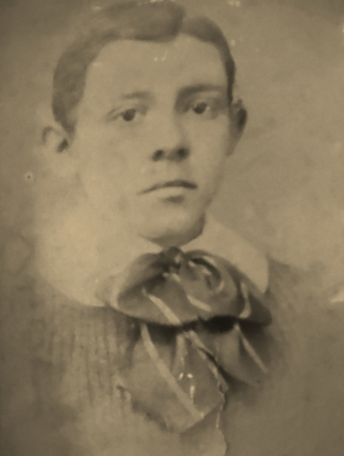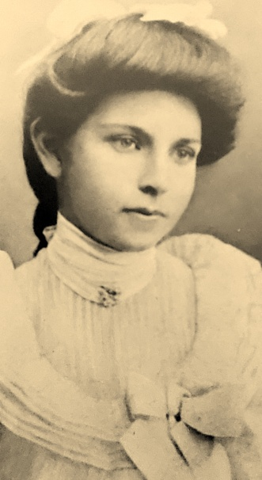

Above: Joseph Harper Hodges and Alice St. Clair Parlin in their youth.
Below: Joseph and Alice Hodges. Behind them, in the photograph on the right, is Henry Grady’s Cherokee Rose bush.

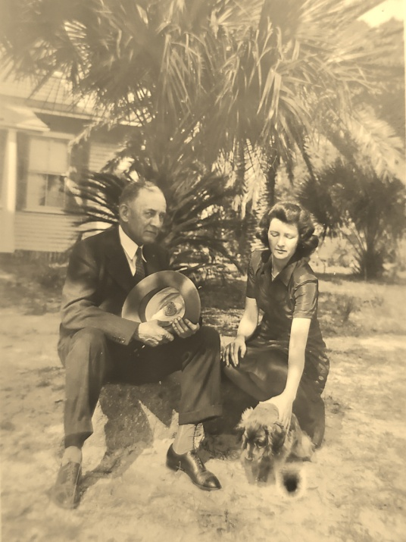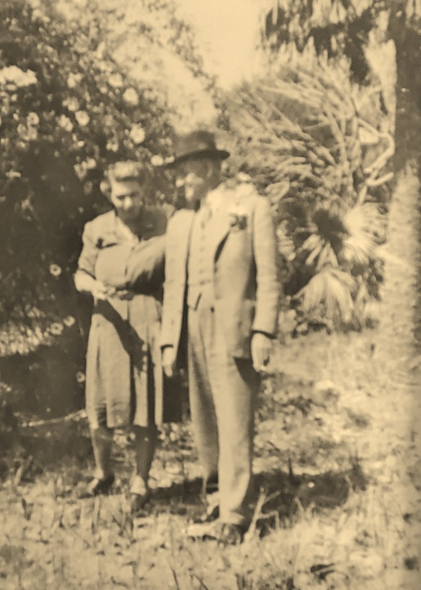

Alice Hodges, or “Nonnie,” as her granddaughter Kathy named her, is remembered as “a legend.” In contrast to her husband, Nonnie was lively and talkative. She loved to tell stories, and she loved to exaggerate, so much so that her niece, Teeny, described her as “a wonderful liar.” She was always laughing; in fact, she would start laughing as soon as she spotted a friend approaching. She also loved to stir up a good argument just for fun, a trait shared by her siblings who would often take the opposite side to get things going. Everybody, according to Teeny, loved both Nonnie and May, Teeny’s mother, and when these two got together with their equally sharp-witted siblings, Alma and Mac, it could be quite a circus! Nonnie, apparently, didn’t care at all about gardening or housekeeping, preferring instead to sit in her rocking chair on the front porch, holding court with whoever stopped by for a visit. If it was the Catholic priests, she would serve them “whiskey showers,” even though she herself was a teetotaler. If it was friends or family, all the porch chairs got to rocking faster and faster as Nonnie threw sand on one side of a subject or the other for laughs. Nonnie wasn’t much of a driver, either; there was a time when Mamam, Nonnie and Nonnie’s daughter, Alice Hodges, were all in the car together and Nonnie, at the wheel, took a turn and accidentally threw her mother onto the roadside. Little Alice, aghast, looked at Nonnie and cried “You have killed my Mamam!” Nonnie was also in the habit of bringing her car to a halt in the driveway by running into the side of the addition at the back of the house. One can only imagine, then, the irony of Nonnie attempting to teach Aunt Libby how to drive. Once, the family’s cook, a black woman named Gentz, watched out the window as Aunt Libby lurched the car backward when she meant to go forward. “My God,” exclaimed Gentz, “she is going to kill us all.”

It appears that Joseph Hodges stopped working for the Apalachicola Northern Railroad shortly after his marriage to Alice. There are two 1912 references to him as Vice-President and Treasurer for the Gulf Manufacturing Company which made veneer, furniture and boxes. In 1918, when he registered for the draft, he said he was employed by the J.H. Hodges Company, his own lumber business, and the 1920 Apalachicola census lists him as a lumber mill operator. His and Alice’s last child, Alice St. Clair Hodges – or “Little Alice,” as she would come to be called - was born in 1921.

1921 was also the year that Henry Grady was publicly honored on the occasion of his seventy-third birthday. On May 14, while sitting at a table going through his mail, thirty Apalachicola businessmen rang the bell at his front door and filed into the front room. One of them announced that they were there to honor him as a highly-esteemed “neighbor and citizen and as a chivalric Christian gentleman.”
Others gave brief talks and presented Henry with “a handsome and expensive traveling set,” after which Nonnie, Alma, and Aunt Libby served the party fruit punch and cake. The following Saturday the editor of the Apalachicola Times delivered more accolades to Henry and printed a letter from him in response to his birthday celebration. Henry’s humility is evident in his words:

…I was almost dazed when they told me they had come to wish me many happy returns
of the day and then in loving and expressive words told me of their friendship for me. I
could not speak; I could only stand and wonder how much I deserved of this to me
undreamed of kindness…above all I will treasure the kind feeling that led you my friends
to come and say what you did.

Sometime during the ensuing decade, Joseph Hodges retired from the lumber business and took up work as a real estate agent, keeping an office in the small building to the left of today’s Tap Room on Commerce Street. He also served two terms as mayor of Apalachicola. The rest of the decade passed fairly uneventfully until the devastating October 1929 stock market crash which plunged the nation into financial chaos. Its effects - combined with Henry Grady’s deteriorating health – would prove fatal for J. E. Grady & Co. In the years after the crash, faithful Grady clients, increasingly, could not pay their rising debts to the business and, in 1933, Henry’s illness forced him to retire from public life. For the first time since his early youth, he was unable to work. Aunt Libby cared for him – as she had done for John - at home. Although he was no longer a presence in the city, he was very much on people’s minds (see Appendix III), and in 1935 the Florida legislature “passed a resolution of congratulation upon his 87th birthday, showing with what high regard he was held throughout the state. The resolution provided that a committee of three members of the legislature personally [confer] the congratulations.” A year and a half later, Henry died of cancer, in his bedroom, the Blue Room on the second floor, during the night of November 24, 1936. He was eighty-eight years old. His obituary reads, in part, as follows:

With the passing of this distinguished and beloved citizen, Apalachicola and all of Florida has
suffered a great loss. Always ready to serve his friends, town and state in any capacity, he will be
greatly missed. His devotion to his family was one of [his] outstanding characteristics showing his
loveable nature and unselfish disposition. His life of 88 years, altho’ completed on this Earth will
forever live on in the minds of those who were privileged to know him.

Mr. Grady was born here May 14, 1848, son of Mr. and Mrs. C. Grady[,] pioneer residents. He was
active in making Florida history until he was forced to retire from public life three years ago
because of ill health…

In the passing of Mr. Grady, an authority of note has been taken, for he was versed in the pioneer
history of Florida and took keen interest in reading and gathering information pertaining to the
growth of this section of the state. He was a member of the Florida Historical [S]ociety and it was
through his efforts that much valuable information was preserved for posterity.

Henry was buried in Chestnut Cemetery in the Grady plot in Chestnut Cemetery. His sister, Cornelia (Mamam) Grady Parlin, who died five years earlier, was buried in the Parlin plot in Magnolia Cemetery.

Libby was Henry’s only heir and, now, and the sole surviving child of Cornelius and Elizabeth Grady. She had just turned seventy-nine and was, no doubt, feeling her years. She had always been the caretaker in the family, but soon – in a reversal of roles – she allowed Nonnie and Dee to look after her. She spent most of her days sitting quietly on the sun-porch of the house she had lived in for nearly fifty years. Its walls held many memories. She could probably see herself chatting away on the crank telephone located just outside her first floor bedroom, and she may have smiled remembering how often she rang up “central” asking for news or gossip. She may have recalled the hours she spent writing out notes and minutes for the Chestnut Cemetery Committee, church committees, and the Apalachicola Chapter of the United Daughters of the Confederacy. She had always wanted to be a member of the UDC, but, of course, wasn’t eligible; the local branch did, however, make her their Recording and Corresponding Secretary for a time. She had been a meticulous housekeeper, but she may have rued barring her nieces and nephews from the upstairs until they were old enough not to disturb things, or wished she hadn’t been so quick to clean up the torn wrappings of Christmas presents which caused the children to worry their gifts would end up in the fireplace. Most of all, she probably reminisced about the family that had been so near and so dear to her – her mother, the father, sister and brother she never knew, her siblings, and her sister Cornelia’s children and grandchildren. She had given them her all. On August 9, 1940 – almost one hundred years after her father first came to Apalachicola - Aunt Libby died of heart failure.

In her will, Libby left everything to be evenly divided among her relatives. But the family – minus Nonnie’s brother Mac who had died of cancer two months earlier and her sister May who died of skin cancer in 1935 - decided to sign the Grady house over to Nonnie and Dee as a “thank you” for having looked after Libby. Ever since then, the house has been referred to as the Grady-Hodges house. In 1957, Kathy Willis came to live with her grandparents at 127 Bay, much as both her uncle John Grady Hodges and grandmother Nonnie had done when they were children. During the year she lived there, Kathy spent a lot of time sitting on the porch, listening to Nonnie’s lively conversations and family stories, stories she would carry with her always. Dee often spoke with Nonnie about relocating to Atlanta, but she refused, citing terrible traffic as the reason – which was likely not entirely true. She had lived there at the bay end of 10th Street since she was five years old, and one can only imagine what a wrenching it would have been to leave. So, they stayed on, living in the big house and selling the Cottage. Opposites in so many ways, they had a loving, happy marriage for over fifty years. Joseph died on September 18, 1963 at the age of eighty-six and was buried in Magnolia Cemetery.

At the time of her husband’s death, Nonnie was seventy-six years old, but as it turned out she would live another quarter of a century. She was a devoted member of Trinity Church and of the Historical Society, and she never lost her love of fun. Her sister, Alma (married to Elroy Neate), lived across 10th Street in the old Ruge house facing the bay; she was an antiques dealer and had a shop behind her house. Not unusually, Alma and Nonnie would go off on antique-hunting trips together for days at a time and no one would know where they were. In the early 1970s, when it was evident that Nonnie needed some help, the family hired an African-American woman named Dolly Miller. Although Dolly never lived at the Grady house (she had a home of her own with her husband on the corner of Avenue I and 8th Street), she was Nonnie’s devoted companion and assistant for the rest of her life. In her last years, Nonnie was home during the day, but spent nearly every night in the company of a few other elderly women at Miss Gordon’s house on Avenue E, an arrangement that she made without informing her family. Alice St. Clair Parlin Hodges was independent right up to the end. Nonnie’s 95th and 100th birthdays were celebrated in grand style at 127 Bay Avenue. Two months before her 101st birthday, she died on September 20, 1987 and is buried in the Parlin plot in Magnolia Cemetery.

In her will, Alice Hodges left the property at 127 Bay Avenue to her three children, John Grady Hodges, Joseph Harper Hodges, Jr and Alice St. Clair Hodges, but it sat empty for a year, with ants and termites making substantial inroads. In 1988, when Nonnie’s granddaughter, Kathy Willis, came down from Tallahassee to visit the house one last time, she finished her farewell tour by exclaiming to her husband, Lee, “They are all still here!” She was referring, of course, to Nunka, Uncle John, Aunt Libby, Nonnie and Dee. And, ringing in her ears, was Nonnie’s oft-repeated desire for Kathy to keep the house in the family if she possibly could. Feeling the pull of the past, Kathy then and there decided on the future of 127 Bay Avenue. Obtaining the deed from her mother and her uncles, Kathy and Lee set about both restoring the house and reestablishing it as the ancestral home of the Grady family. A few years later, they were also able to buy back “the Cottage” on Lots 4 and 5. Since their ownership, the house and garden at 127 Bay Avenue have been the site of numerous christenings, weddings, birthdays, and other gatherings of family and close friends. It is now also Kathy Willis’s permanent home. Looking much as it did a century ago and still full of family furnishings, papers, photographs, books, and heirlooms, the property is cherished by Grady family members everywhere for the deep sense of place, kinship and belonging that it gives them all.

*****
APPENDIX I

ALICE ST.CLAIR HARTMAN, WIFE OF JOHN E. GRADY, and HER FAMILY

Just when and why Frank St. Clair Hartman, who always used his middle name, came to Apalachicola is unclear. He and his wife, Virginia Jane (“Jennie”) Tompkins, married in 1854 in their hometown of Scottsville, VA, where they had two daughters, Alice (born1861)and Sarah or “Sallie” (born 1865). Over the next thirty years, St. Clair moved his family around a lot: in 1860, he was in Richmond, VA working in the “manufacture of guano,” in 1870, he was a farmer in Lovington, VA, and in 1880, he was in Newnan, GA, employed as a “commercial traveler” or traveling salesman. Jennie died in Apalachicola in August 1883, so the family must have come to Apalachicola between 1880 and 1883. One year after Jennie’s death, Alice (born 1861) married John Grady and, six days later, Sallie (born 1865) married Jacinto V. Pereira. Widowed St. Clair Hartman continued to live and work in Apalachicola – he was Inspector of Dredging in 1890 – until his death from “la grippe” in 1897. He was buried alongside his wife and daughter, Alice, in Chestnut Cemetery.
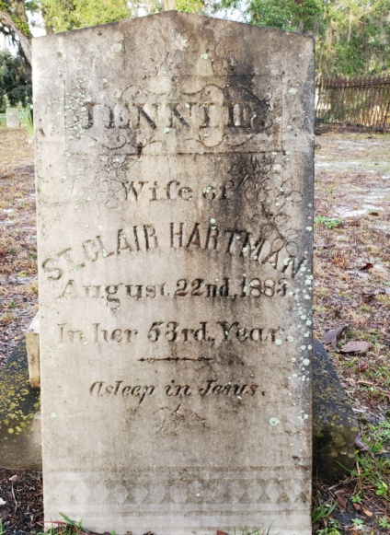
Gravestone of
Virginia Jane (“Jennie”) Tomkins Hartman,
Chestnut Cemetery,
Apalachicola, Florida

Sallie’s husband, Jacinto Valentine Pereira, may have been the builder of the Grady home at 127 Bay Avenue. (See Appendix II.) He has an unusual and mysterious story. The “official” version of it, published in 1922, reads as follows:

Jacinto Valentine Pereira, Scottsville, Virginia. Banker. Born in Liverpool, England in 1850; son of Jacinto and Eliza Pereira; educated in St. James Episcopal School, Mechanics Institute, Liverpool; married in Apalachicola, Florida in 1884 to Sarah Gilmer Hartman. Was engaged in shipping business in Liverpool; left England in 1877 and moved to Georgia and engaged in lumber business; now in banking. President of Fidelity Bank; treasurer of V. B. Jeffries Company; Town treasurer of Scottsville; member of the American Bankers Association and the Virginia Bankers Association; Senior Warden at St. John’s Church, Scottsville. Recreations: swimming, horse-back riding. Has travelled extensively in Europe. Crossed the Atlantic twelve times. Democrat. Episcopalian.

Research corroborates the above and reveals a little more than this rendition of Pereira’s story, which only touches on his time in Apalachicola. His name appears on an 1883 list of communicants at Trinity Church. In 1886, he became a naturalized citizen and was elected to serve on the Vestry at Trinity. Two years later, along with John E. Grady, he was re-elected to the Vestry. In 1889, Pereira’s name appears on a list of lay deputies of Trinity, and in 1890, he is mentioned as a co-owner of the D M Munroe & Co sawmill which was presumably somewhere in Franklin County. The 1890 census was destroyed by fire, so there is no official record of his whereabouts that year. Pereira doesn’t show up again until an 1899 publication of the American Bankers Association, in which he is listed as President of the Fidelity Bank, back in Sallie’s birth-town of Scottsville, VA. It appears, then, that Jacinto arrived in Apalachicola sometime between 1878 and 1883 and that he and Sallie left sometime between 1889 and 1899. Later, Jacinto’s death certificate, signed by Sallie, gives his mother’s name as British-born Ann Venn (not Eliza, as stated above) and adds that his father, Jacinto Pereira, was born in Liverpool, not the Azores as the name would indicate.

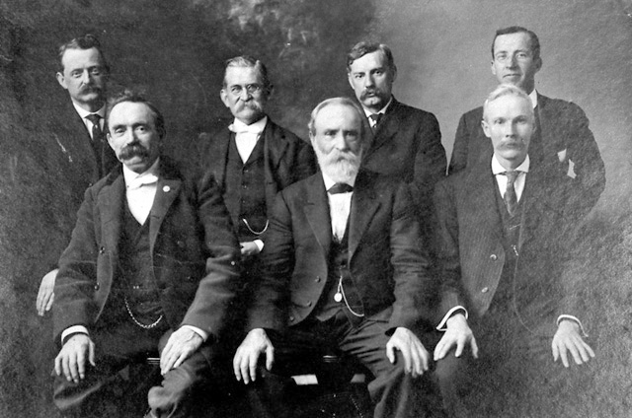

Scottsville, Virginia Town Council, 1909
J. V. Pereira, first on left, front row
Image Number Roll One, Neg 2A

The mystery in this story comes with the discovery of a notation, probably made by Henry Grady, in the records of Trinity Church. Next to the announcement of Sarah G. Hartman’s marriage to Jacinto V. Pereira on September 30, 1884, but in different handwriting, is the following statement: “Mr. Pereira was former Joseph Jones, but had his name legally changed.” Apart from the startling fact that a man named Joseph Jones would change his name to Jacinto Valentine Pereira (and not vice-versa), this revelation gives rise to questions that may no longer be answerable.

After leaving Apalachicola, J. V. Pereira contributed much to the life of Scottsville,VA, as bank president, town council member and builder of the Travelers’ Rest Hotel on Main Street. However, when a Lynchburg attorney sued him, he became depressed and suicidal. On February 14th, Valentine’s day, 1925, just before eight in the morning, Jacinto Valentine Pereira jumped from a 30-foot high porch on his hotel building. He lived for thirty minutes before dying from the concussion he incurred. Sallie continued to live for an other thirty-five years until her death, at age 94, from arteriosclerosis and a pulmonary edema in May, 1960.

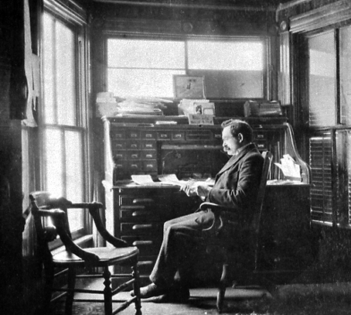

Jacinto V. Pereira, Bank President, 1920
Image Number Roll 13, Neg 12A, Scottsville Museum, Scottsville, VA

*******

APPENDIX II
THE HOUSE AT 127 BAY AVENUE (Legal Description: Lots 1-5, Block 45)

It appears that the Grady family, about the time of John and Alice’s marriage in 1884, was still living in the original Grady house on the corner of Avenue C and 4th Street (Lot 1, Block 10). In 1878, Mrs. Grady had added onto her half-lot with the purchase of the west half and, in 1881, she again increased the size of her property by buying the lot next door (Lot 2, Block 10). The following year, she may have added a second floor to their home, as evidenced by a rise in her real estate taxes. Then, in 1884, there is a big change: records show Henry paying property taxes on Lots 1-5 in Block 45 and Lots 6-10 in Block 37 – that is, he now owned both sides of 10th Street where it meets Bay Avenue. Tax bills indicate that there were no structures on either property.

But, that same year, six weeks after John’s marriage to Alice, Henry sold his newly acquired Lots 1-5 inBlock 45 to Jacinto Pereira, Alice’s sister’s new husband. A little more than a year later – and two months after Alice’s death – two inexplicable real estate transactions occurred: on December 8, 1885, Jacinto Pereira sold lots 1-5, Block 45 to his wife’s father, St. Clair Hartman, who on the very same day sold the same property back to his daughter Sarah, Jacinto’s wife. Unfortunately, the real estate tax records for the ensuing three years have disappeared. The next year for which they are available is 1888, by which time the taxes on Sarah Pereira’s Lots 1-5 in Block 45 were nearly ten times higher, indicating that a house and perhaps other structures, like the horse stable and tack room, were now occupying the property. Thus, somewhere between the beginning of 1886 and 1888, is a likely date for the construction of the house at 127 Bay Avenue. Finally, on February 20, 1891 Sarah Hartman sold the property back to Henry Grady for $2,700. Henry signed a $2,000 mortgage, dated the same day, from local hardware dealer August Hoppe.

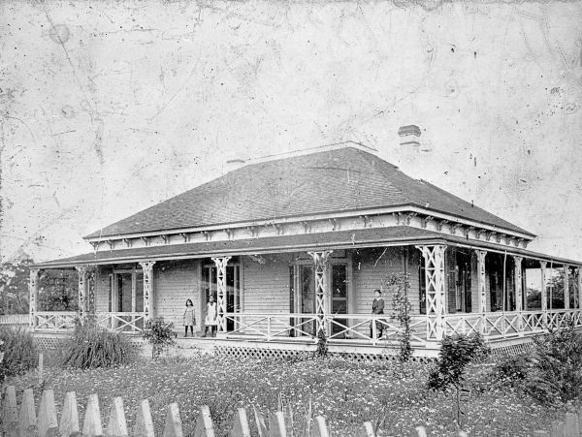
127 Bay Avenue before the addition of the second story.
Built c. 1887

As to the date of the second story addition, two pieces of evidence, taken together, suggest that it was 1892. One is an 1891 bill, found among the papers at 127, for a very large amount of lumber, and the other is a photograph taken from the second story of the Grady House which shows the new Courthouse, not built until 1892, in Washington Square. This would mean that the second floor was added to the house about a year after the Grady family moved into it. Later photos from the turn of the century show, in addition to the elegant two-story home and horse stable, a windmill and a chicken coop on the property. They also reveal that in front of the house and across Bay Avenue there was an open beach; the dense marsh grass there now arrived many years later, after the building of a dam upriver and the making of a cut through St. George Island.

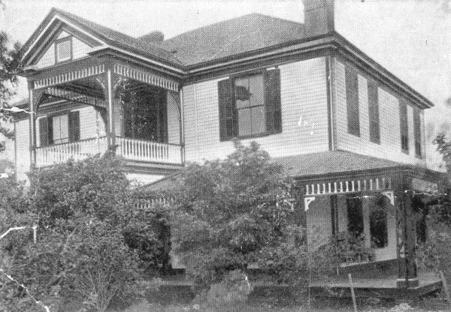
127 Bay Avenue with its
second story

The house served the family well for almost a century, but toward the close of the long life of Alice Hodges it fell into disrepair and then disuse . Brought back to its former glory in the early 1990s by Kathy and Lee Willis, it stands proud today. As Lee Willis wrote almost thirty years ago,

Rising above the shores of the Gulf of Mexico in the Panhandle of Florida, there is a
magnificent place that engages the eye as well as the spirit with dramatic vistas of
Apalachicola Bay and palm trees swaying in the late afternoon sun. A breeze stirs and
the air is filled with the smell of salt air. This is the front porch of the Grady-Hodges
House, a place with simple natural beauty that evokes the heritage and tradition of the
Victorian era where the warmth and graciousness from another time have never gone
out of fashion. The crimson sunrises over the Bay start another day in the ideal setting
for fun and relaxation, a place to let the world turn slower and collect one’s perspective
of the events of our time. ..The Grady-Hodges House is a celebration of the hallmarks of southern living – family, friendship and front porch hospitality.

*******

APPENDIX III

May, 14, 1932

Dear Mr. Grady:

As an old friend I desire to congratulate you on having reached another milestone on the long trail. With greater success than any man I know you have passed the stages of pitfalls and thorns, and I sincerely hope that sunshine and flowers may attend you down the twilight years.

Blessed with unusual courage and fortitude, you have helped, cheered and encouraged your fellow wayfarers. Your strength has supported the weak and faltering, and you have smoothed the rough places for those who come later.

If you have not accumulated worldly wealth, that fact is of no importance, save as testimony to your unselfish altruism. Instead you have amassed a fortune in the love, esteem and admiration of your fellows, beside which wealth would be paltry.

The long years which are behind you have brought you no enemy, only friends. Your heart harbors no thought of hatred or vindictiveness toward any man, to poison your soul. Your life has been spent in the service of others, and no part of it wasted upon selfish ends.

Unless this be success (as I believe it is) our lifelong faith would be at fault. I trust that you may be conscious of the contentment and happiness which you so richly deserve.

Yours sincerely,
R. Don McLeod, Jr.
arles Parlin as a young man. In later years,he was mde Surveyor General of Florida, hence the title “General.”

Some genealogists say Cornelius was from Cork, Ireland, but family lore says he came from Killarney.
1840 U.S. Census, Apalachicola, FL
1850 U.S. Census, Apalachicola, FL
Commercial Advertiser, March 22, 1845.
William Valleau was born October 26, 1802 in New York City. The reasons for his going to Apalachicola are unknown. William’s 2x-great-grandfather, Essaie Valleau, a Huguenot from the Ile de Re on France’s Atlantic coast, had been forced to flee his homeland with the revocation of the Edict of Nantes. He went with his family to New Rochelle, NY. See more about the Valleau family in Pierre Fauconnier and His Descendants with Some Account of the Allied Valleaux, Abraham Ernest Helffenstein, Philadelphia, 1911, pp.49-50.
This title for Valleau was found in a real estate deed from Valleau to Dr. John Gorrie, Book E, Page 233.
It is likely that an Edward Grady, born in Cork, Ireland, in 1817 and a resident of Pensacola, was a brother of Patrick, Cornelius, and Jeremiah; Edward’s first son, born in 1848, was also named Henry. See US Census records for Pensacola 1840-1880. Edward Grady was a stone cutter.
The Grady house was later moved from its Lot 1, Block 10 location to the Fifty Cherry Street property (currently a guest house) on Lot 7, Block 3 and a first-floor was built underneath it.
History of Florida, Past and Present, Historical and Biographical, Vol. 3, Harry Gardner Cutler, 1923, p.265.
Lee Willis left notes to this effect.
After I wrote this document, I found a notice in the December 3, 1856 Commercial Advertiser, listing several properties and “a family of Negro slaves” being sold at auction by Patrick Grady, suggesting that he was preparing to leave town. – P.R.
U.S. Slave Schedules, 1840, 1850 and 1860.
They are on the federal censuses for Jersey City in 1870 and 1880. The 1890 census burned. Jane Valleau died in 1899 in Jersey City.
Outposts on the Gulf, William Warren Rogers, 1986, p. 71. Note that one of the two women to whom this book is dedicated is Alice Parlin Hodges.
Cutler, loc.cit
This boy was William John Breck Oven who became a successful lawyer and Franklin County judge.
Explanation given by Bess Porter in an interview with Margaret Key, July 11, 1977.
Cutler, loc.cit.
See Henry Grady’s obituary, reprinted in the Apalachicola Times, November 23, 2016.
The Register of Trinity Church, 1837-1899
Over the course of his life, Charles would often return to Maine for reunions of the Grand Army of the Republic, a fraternal organization of Union military men.
The Parlin Genealogy, Frank Edson Parlin.
Annual Report of the National Board of Health, 1879-1885, page 388.
This is Kathy Willis’ interpretation from the many stories she heard about Henry.
Cutler, loc. cit.
When the Gorrie Bridge was being built, Henry told his niece, Alice Parlin, that many Indian mounds were bulldozed and used as fill under the causeway between the two parts of the bridge.
See Pierce Mounds Complex, An Ancient Capital in Northwest Florida, Nancy Marie White, Department of Anthropology, University of South Florida, 2013. Available online.
December 5, 1884, deed from H.W. Johnston to W. Orman, M.T. Alexander and John E. Grady. Book C, Page 126.
The Morning News, Savannah, GA, August 24, 1885
Pensacola Daily News, February 14, 1890, reprinted in the Apalachicola Times, March 1, 2018, page A5
There was at the same time a J. E. Grady & Sons, grocers, in Savannah, GA. A photograph of that building shows it as having the number 133 which has caused confusion. J.E. Grady & Co in Savannah, owned by James E. Grady, was located at 133 Bay Street; J. E. Grady & Co in Apalachicola was located at 38 Water Street. James E. Grady’s son, Robert, married Clara Sloan Grady, granddaughter of Patrick Grady of Apalachicola. They had a daughter, Edith Grady, who Kathy Willis knew. See the Patrick Grady Family Tree in the appendix.
Bismark Daily Tribune, October 29, 1890
According to Lee Willis’s papers, “John Grady had a horse and buggy and he would drive out to Eleven Mile and ‘take on drinks.’ He would take a driver to drive him home.”
A Concise History of Apalachicola, Apalachicola Times, October 31, 1974).
“Within Six Months Apalachicola has Been Rebuilt,” Apalachicola Times, November 4, 1902
This event is described in detail in the April 2, 1910 edition of the Apalachicola Times.
A quote from Kathy Willis’s good friend, Jane Daniel
Same source
These are the Lumber Trade Journal, Vol. 60 (1912), page 40 and the Wood-Worker, Vol.31 (1912), page 58. Both were found online.
Apalachicola Times, Saturday, May 21, 1921.
Henry Grady’s obituary in the Apalachicola Times, reprinted in the November 23, 2016 Apalachicola Times.
loc. cit.
Record of Wills, Volume 3, page 198, Franklin County Courthouse, Apalachicola.
Annual Report of the Chief of Engineers, US Army, to the Secretary of War for the Year 1890, p.1692
Trinity Church burial records. La grippe is the French word for influenza and is often found in 19th century US death records.
Who’s Who in Finance and Banking, John William Leonard, ed., 1922, page 532
Death records, Scottsville, Virginia.
Deed Book C, Page 111.
Deed Book C, Page 448, signed by John E. Grady, Notary Public.
Deed Book C, Page 449, signed by John E. Grady, Notary Public.

